Software Design Document
(SDD) Report



Project Title : AI-Powered Virtual Try-On System with Real-Time AR
and Cloud Integration

Submitted by :
Muhammad Shifan Saeed
F22BINFT1M01149 (3M)

Submitted to :
Ms.Kainat

Department of Information Technology
Faculty of Computing
The Islamia University of Bahawalpur

Table of Contents
 | Summary | 3
1 | Introduction  1.1 Purpose of the Document  1.2 Scope of the System  1.3 Definitions, Acronyms, and Abbreviations | 4
2 | System Overview  2.1 User Classes and Characteristics  2.2 Operating Environment | 5
3 | Design Considerations  3.1 Assumptions  3.2 Constraints  3.3 Design Goals  3.4 Design Methodology | 5
4 | System Architecture  4.1 Architectural Overview  4.2 High-Level Architecture Diagram  4.3 Architectural Style | 6
5 | Data Design  5.1 Database Overview  5.2 Data Entities and Descriptions  5.3 Entity Relationship Diagram  5.4 Data Integrity and Validation | 7
6 | Component Design  6.1 Major System Components  6.2 AI Engine Design  6.3 AR Rendering Module | 8
7 | Interface Design  7.1 User Interface Design Principles  7.2 User Interface Screens  7.3 Input Validation and Error Handling | 8
8 | UML Diagrams Description  8.1 Class Diagram  8.2 Sequence Diagram  8.3 Use Case Diagram | 9
9 | Security Design  9.1 Authentication and Authorization  9.2 Data Security and Privacy | 11
10 | Assumptions and Constraints | 11
11 | Future Enhancements | 11
12 | Conclusion | 11
Summary
This Summary Report provides a concise yet comprehensive overview of the AI-Powered Virtual Try-On System with Real-Time AR and Cloud Integration. The project focuses on designing and developing an intelligent virtual try-on platform that leverages Artificial Intelligence (AI), Augmented Reality (AR), and Cloud Computing technologies to deliver a realistic and interactive user experience.
The report begins by outlining the purpose and scope of the system, emphasizing its academic relevance and practical applicability. The system is designed to allow users to virtually try products such as clothing and accessories in real time using camera-enabled devices, thereby reducing physical dependency and enhancing digital shopping experiences.
The system overview highlights the key user classes, including end users, administrators, and background system services. It explains how each user interacts with the system and contributes to its overall functionality. The operating environment is discussed to clarify platform compatibility and deployment conditions.
The design considerations section summarizes the core assumptions, constraints, and design goals that guided system development. These include real-time performance requirements, device and network limitations, and the need for scalability, accuracy, and security. The adopted design methodology, based on a modular MVC architecture combined with microservices, ensures maintainability and future extensibility.
The system architecture is summarized by describing the client–server model integrated with cloud services. The client handles user interaction and visualization, while the server manages business logic, AI processing, AR rendering, and persistent data storage. This architectural approach supports efficient processing and scalable deployment.
The data design section provides an overview of how system data is structured and managed. It summarizes key entities such as users, products, and virtual try-on sessions, along with their relationships. The use of relational databases and cloud object storage ensures data integrity, reliability, and efficient media handling.
The component design overview explains the responsibilities of major system modules, including the user module, AI engine, AR renderer, admin module, and cloud services. Special emphasis is placed on the AI engine and AR module, which together enable accurate detection, alignment, and real-time visualization of virtual products.
The interface design summary highlights the system’s user-centered design approach. It focuses on usability, responsiveness, and real-time feedback across key screens such as the home page, try-on interface, authentication pages, and administrative dashboard.
The UML diagrams section is summarized by explaining how class, sequence, and use case diagrams are used to model system structure, interactions, and user functionalities. These diagrams provide a clear visual representation of system behavior and relationships.
The security design overview discusses the importance of authentication, authorization, encrypted communication, and user data privacy. Security measures are incorporated to protect sensitive data and ensure safe system usage..
1. Introduction
1.1 Purpose of the Document
This Software Design Document (SDD) presents a comprehensive and detailed design specification for the AI-Powered Virtual Try-On System with Real-Time AR and Cloud Integration. The primary purpose of this document is to describe the system architecture, components, data structures, interfaces, and design decisions in a clear and professional manner. It is intended to support academic evaluation, system development, future maintenance, and scalability planning. This document serves as a technical reference for developers, instructors, examiners, and other stakeholders involved in the project lifecycle.
1.2 Scope of the System
The scope of this system covers the design and implementation of an intelligent virtual try-on platform that enables users to visualize products such as clothing, accessories, and eyewear in real time using their device camera. The system integrates Artificial Intelligence (AI) for image processing and body/face detection, Augmented Reality (AR) for realistic overlay and visualization, and Cloud Computing for data storage, processing, and scalability. The system is designed to operate as a web-based or mobile-based application and can be extended for e-commerce platforms in the future.

1.3 Definitions, Acronyms, and Abbreviations
Term | Description
AI | Artificial Intelligence
AR | Augmented Reality
SDD | Software Design Document
MVC | Model View Controller
API | Application Programming Interface
UI | User Interface
UX | User Experience
CNN | Convolutional Neural Network

2. System Overview
The AI-Powered Virtual Try-On System is an intelligent, cloud-enabled application that provides users with an immersive virtual try-on experience. The system captures live images or video streams from the user’s device, processes them using AI-based computer vision algorithms, and renders virtual products using AR technology. Cloud services are utilized to manage user data, product models, analytics, and system scalability.
2.1 User Classes and Characteristics
User Class | Description
End User | Individuals who use the system to virtually try products and view results in real time
Administrator | Authorized personnel responsible for managing products, users, system settings, and analytics
System Services | Background services responsible for AI inference, AR rendering, and cloud operations

2.2 Operating Environment
The system is designed to operate on modern web browsers and mobile devices with camera support. The backend services run on cloud infrastructure, supporting scalable processing and storage.

3. Design Considerations
3.1 Assumptions
- Users possess a camera-enabled device such as a smartphone, tablet, or webcam-enabled computer
- The system has access to pre-trained AI models for detection and alignment
- Internet connectivity is available for cloud communication
3.2 Constraints
- Real-time performance constraints for AR rendering
- Device hardware limitations such as camera quality and processing power
- Network latency and bandwidth limitations

3.3 Design Goals
- High accuracy in product alignment and visualization
- Low latency for real-time interaction
- Scalable and maintainable system architecture
- Secure handling of user data
3.4 Design Methodology
The system follows a modular, MVC-based architecture combined with microservices. Each major functionality such as AI processing, AR rendering, and data management is encapsulated in independent modules to enhance maintainability and scalability.

4. System Architecture
4.1 Architectural Overview
The system adopts a Client–Server Architecture integrated with Cloud-Based Services. The client handles user interaction and real-time visualization, while the server manages business logic, AI processing, and persistent storage.
4.2 High-Level Architecture Diagram
User Device

Web / Mobile Client

API Gateway

AR Engine
Database
AI Service

Cloud Storage

4.3 Architectural Style
- MVC pattern for separation of concerns
- Microservices architecture for AI and AR modules
- Cloud-native deployment for scalability and availability

5. Data Design
5.1 Database Overview
The system uses a relational database to store structured data such as user profiles and product metadata, while cloud object storage is used for storing images, videos, and 3D models.
5.2 Data Entities and Descriptions
Entity | Description
User | Stores personal and authentication information
Product | Stores product details and 3D model references
TryOnSession | Stores session data for each virtual try-on
Admin | Stores administrative credentials and roles

5.3 ER Diagram (Textual Representation)
User (user_id) ---< TryOnSession >--- Product (product_id)

5.4 Data Integrity and Validation
- Primary and foreign key constraints are enforced
- Input validation is applied at both client and server levels

6. Component Design
6.1 Major System Components
Component | Responsibility
User Module | Handles authentication, registration, and profile management
AI Engine | Performs image processing, detection, and fitting
AR Renderer | Renders virtual products in real time
Admin Module | Manages system configuration and content
Cloud Module | Handles storage, analytics, and scalability

6.2 AI Engine Design
The AI Engine is responsible for analyzing images using deep learning models such as CNNs. It performs facial landmark detection, body pose estimation, and product alignment to ensure accurate try-on results.

6.3 AR Rendering Module
The AR module overlays 3D product models onto the user’s live camera feed. It continuously tracks movement and adjusts rendering in real time to provide a realistic experience.

7. Interface Design
7.1 User Interface Design Principles
- Clean and minimalistic layout
- Intuitive navigation
- Real-time visual feedback
- Responsive design for multiple devices
7.2 User Interface Screens
Screen | Description
Home Page | Displays product categories and recommendations
Try-On Screen | Shows live AR visualization
Login/Register | Handles user authentication
Profile Page | Displays user history and preferences
Admin Dashboard | Provides management tools and analytics

7.3 Input Validation and Error Handling
- Mandatory field checks
- Format validation for email and passwords
- User-friendly error messages

8. UML Diagrams Description
8.1 Class Diagram
The class diagram illustrates the system structure, including classes such as User, Product, Tryon Session, AI Engine, and AR Module, along with their attributes, methods, and relationships.
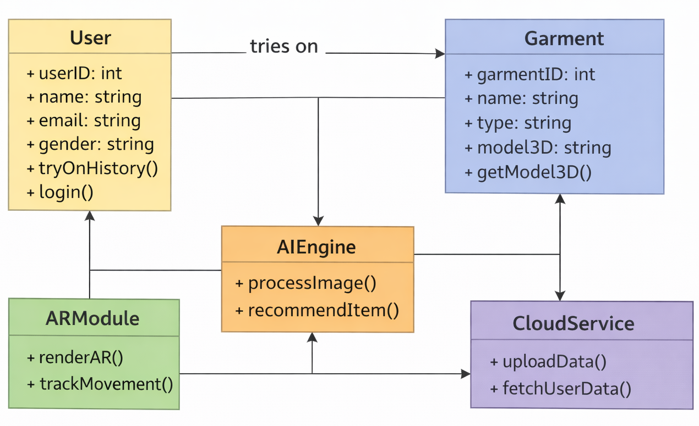

Fig.1 : Class Diagram

8.2 Sequence Diagram
The sequence diagram represents the flow of interactions during a virtual try-on session, starting from user input to AI processing, AR rendering, and result display.
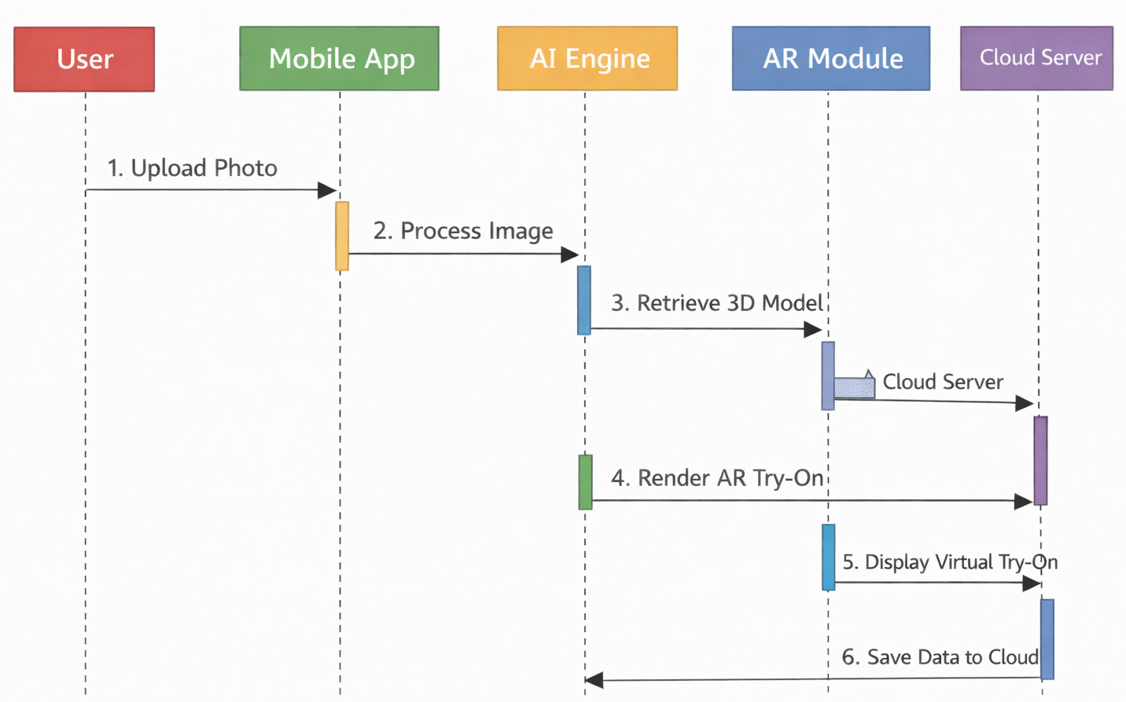
Fig.2 : Sequence Diagram

8.3 Use Case Diagram
The use case diagram identifies interactions between actors (End User and Admin) and the system, highlighting major functionalities such as uploading images, selecting products, managing data, and accessing cloud storage.
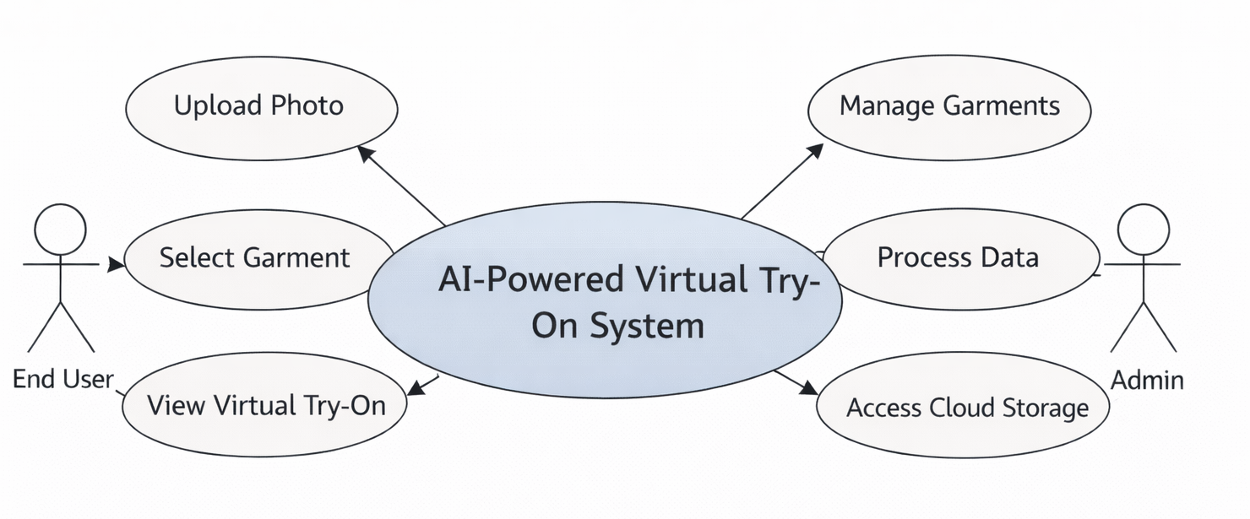

Fig.3 : User Case Diagram
9. Security Design
9.1 Authentication and Authorization
- Secure login mechanisms
- Role-based access control
- Token-based authentication for APIs
9.2 Data Security and Privacy
- Encrypted data transmission
- Secure cloud storage
- User consent for image processing

10. Assumptions and Constraints
10.1 Assumptions
- AI models are pre-trained and optimized
- Cloud infrastructure is reliable and scalable
10.2 Constraints
- Network latency in low-bandwidth environments
- Device compatibility limitations

11. Future Enhancements
- Integration with e-commerce payment systems
- Support for additional product categories
- Improved AI accuracy through model retraining
- Multi-language user interface support

12. Conclusion
This Software Design Document provides a detailed and professional design blueprint for the AI-Powered Virtual Try-On System with Real-Time AR and Cloud Integration. The proposed architecture ensures scalability, security, and high performance, making the system suitable for academic
evaluation as well as real-world applications. The integration of AI, AR, and cloud technologies positions the system as a modern and future-ready solution.

